CASE STUDY 4: EXAMINATION RESULT AND GRACE-MARK VALIDATION
AUTOMATED MARKS PROCESSING AND CONDITIONAL GRACE POLICY
1 PROBLEM STATEMENT
Develop an academic mark audit program that evaluates multi-subject student scores, identifies borderline failure subjects (marks between 35 and 39 out of 100), applies a conditional grace mark policy (maximum 5 total marks allowed), and generates official pass/fail results.
PDF
2 OBJECTIVES
- Parse individual student subject marks against a passing threshold of 40.
PDF
- Identify borderline subjects where score is within $\left[35,39\right]$.
PDF
- Distribute available grace marks (pool = 5) to elevate failing subjects to 40.
PDF
- Determine final PASS / PASS (With Grace) / FAIL status.
PDF
3 KEY ASSUMPTIONS
Grace marks are strictly limited to a max cumulative total of 5 per student. Students with scores below 35 in any subject cannot pass.
PDF+ 1
4 ALGORITHM
- For each student, inspect marks in all subjects.
PDF
- Count subjects scoring $<40$. If any subject $<35$, grace cannot rescue the student.
PDF
- For subjects scoring 35-39, calculate required deficit = $\left(40-\text{mark}\right)$.
PDF
- If cumulative deficit $≤5$, apply grace to update scores to 40 and assign "PASS (With Grace)".
PDF
- Otherwise, retain original marks and assign "FAIL".
PDF
5 FLOWCHART REPRESENTATION
Plaintext
[Start] -> [Read Student Marks] -> [Any Mark < 35? Yes: Mark FAIL]
-> [Calculate Deficit for Marks in 35-39] -> [Sum Deficits <= 5?]
-> [Yes: Add Grace, Set PASS (With Grace)] -> [No: Mark FAIL] -> [End]
```[cite: 7]

## 6 PSEUDOCODE
```text
FUNCTION process_exam_results(students):
FOR student IN students:
marks = student.marks
grace_needed = SUM(40 - m FOR m IN marks IF 35 <= m < 40)
has_hard_fail = ANY(m < 35 FOR m IN marks)
IF NOT has_hard_fail AND 0 < grace_needed <= 5:
final_marks = [40 IF 35 <= m < 40 ELSE m FOR m IN marks]
status = "PASS (With Grace)"
ELSE IF ALL(m >= 40 FOR m IN marks):
status = "PASS"
ELSE:
status = "FAIL"
PRINT student, original, grace_applied, final_marks, status
```[cite: 8]

## 7 PYTHON SOURCE CODE
```python
students = [
{"id": "101", "name": "Anil", "marks": [36, 75, 82]},
{"id": "102", "name": "Bhavana", "marks": [32, 60, 70]},
{"id": "103", "name": "Charan", "marks": [85, 90, 92]},
{"id": "104", "name": "Divya", "marks": [38, 37, 80]}
]

print(f"{'ID':<6}{'Name':<12}{'Original Marks':<18}{'Grace':<8}{'Final Marks':<18}{'Status'}")
print("-" * 75)

for s in students:
orig = list(s["marks"])
final = list(orig)
hard_fail = any(m < 35 for m in orig)
deficits = [40 - m for m in orig if 35 <= m < 40]
tot_grace = sum(deficits)

if all(m >= 40 for m in orig):
status = "PASS"
applied = 0
elif not hard_fail and tot_grace <= 5:
final = [40 if 35 <= m < 40 else m for m in orig]
status = "PASS (With Grace)"
applied = tot_grace
else:
status = "FAIL"
applied = 0

print(f"{s['id']:<6}{s['name']:<12}{str(orig):<18}{applied:<8}{str(final):<18}{status}")
```[cite: 8]

## 8 TEST CASES
| Student | Original Marks | Grace Applied | Final Status |
| :--- | :--- | :--- | :--- |
| **Anil**[cite: 8] | $[36, 75, 82]$[cite: 8] | 4[cite: 8] | PASS (With Grace)[cite: 8] |
| **Divya**[cite: 8] | $[38, 37, 80]$[cite: 8] | 0 (Deficit > 5)[cite: 8] | FAIL[cite: 8] |

## 9 OUTPUT SCREENSHOTS
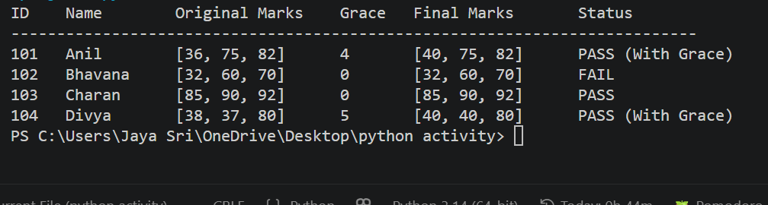
## 10 CONCLUSION
The automated mark validation module ensures rigorous and transparent conditional grace mark distribution while strictly adhering to hard-fail boundaries.

